**A PROJECT**

**ON**

**IOT Based Parking System**



**Kunapareddy Sainath 105119474057**

**MECs**

**2019-2022**

**Project submitted in partial fulfilment for the award of the degree of**

**BACHELOR OF SCIENCE**

**By**

**Osmania University, Hyderabad-500007**



**Certificate**

This is to certify that project work entitled

**IOT Based Parking System**

Submitted by

**Kunapareddy Sainath 1051-19-474-057**

As a part of their curriculum in the Department of Electronics

**Aurora's Degree and P.G College**

Chikkadpally, Hyderabad-500020

This work has been carried out under my guidance.

H.O.D MentorExternal Examiner

**C.Aruna R Sravan Kumar**

**ANNEXURE-1**

**DECLARATION**

I hereby declare that the project entitled **IOT Based Parking System** an original work done by us and has been submitted to the Department of Electronics, Osmania University, Hyderabad in partial fulfillment of the award of the Degree of Bachelor of Science. This report has not been submitted anywhere else for the award of any other degree or diploma or certificate.

**STUDENT NAME SIGNATURE**

Kunapareddy Sainath

**Annexure -2**

**Certification**

This is to certify that project report title **IOT Based Parking System** submitted in partial fulfillment for the award of Degree of Bachelor of Science, Osmania University, Hyderabad was carried out by Kunapareddy Sainath rollno:1051-19-474-057 under my guidance. This has not been submitted to any other University or institution for the award of any degree or diploma or certificate.

Name of the mentor Signature of the mentor

**R Sravan Kumar**

**ACKNOWLEDGEMENT**

My profound thanks to **DR. VISWANADHAM BULUSU,** Principal of Aurora's Degree and P.G College, Chikkadpally for extending his support and guidance in executing my project.

I also wish to thank our Head of the Department **MRS.C ARUNA** for providing me the opportunity to do a project that builds up my career.

I would like to extend my deepest gratitude to my Mentor **R Sravan Kumar** for the constant support and guidance during my project.

I would like to express my special thanks and gratitude to **Hameed Raza**, Director, Innovative Technologies, Hyderabad for giving an opportunity to do project in their esteemed organization.



**S.NO** **CONTENTS pGNO**

1. **ABSTRACT**
2. **INTRODUCTION**
3. **POWER SUPPLY**
4. **MICROCONTROLLER**
5. **LCD**
6. **IR SENSOR**
7. **SOFTWARE TOOLS**
8. **CONCLUSION**
9. **BIBILOGRAPHY**

**ABSTRACT**

Now days in many multiplex systems there is a severe problem for car parking systems. There are many slots for car parking, so to park a car one has to look for the all lanes. Moreover there is a lot of men labour involved for this process for which there is lot of investment. So the need is to develop a system which indicates directly which parking slot is vacant in any lane. The project involves a system including infrared transmitter and receiver in every lane and a LED & LCD display. So the person entering parking area can view using IoT module involved and can decide which slot to enter so as to park the car.

Conventionally, car parking systems does not have any intelligent monitoring system. Parking slots are monitored by human beings. All vehicles enter into the parking area and time waste for searching for parking slot. Sometimes it creates blockage. Condition become worse when there are multiple parking lanes and each lane have multiple parking slots. Use of automated system for car parking monitoring will reduce the human efforts.

Here we are using IR sensors to detect the vehicle in that parking slot. So if it is occupied that information is available in the web and free slots are also shown so that one can book the slot before coming itself using IoT. This is to avoid waiting. We are using AT89S52 as our controller and IoT module is interfaced to view the slots using internet.

This project uses regulated 5V, 500mA power supply. Unregulated 12V DC is used for relay. 7805 three terminal voltage regulator is used for voltage regulation. Bridge type full wave rectifier is used to rectify the ac output of secondary of 230/12V step down transformer.

**Block Diagram:**

Arduino

**MCU**

IR sensor

Slot 1

16X2 LCD

IR sensor

Slot 2

Contrast

IR sensor

Slot 3

IR sensor

Slot 4

WiFi - IoT

Module

ESP8266

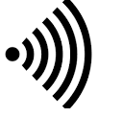

Crystal

Reset

circuit

Power supply to all sections

Step down T/F

Bridge Rectifier

Filter Circuit

Regulator

**INTRODUCTION**

**INTRODUCTION TO EMBEDDED SYSTEMS**

An embedded system can be defined as a computing device that does a specific focused job. Appliances such as the air-conditioner, VCD player, DVD player, printer, fax machine, mobile phone etc. are examples of embedded systems. Each of these appliances will have a processor and special hardware to meet the specific requirement of the application along with the embedded software that is executed by the processor for meeting that specific requirement. The embedded software is also called “firm ware”. The desktop/laptop computer is a general purpose computer. You can use it for a variety of applications such as playing games, *word* processing, accounting, software development and so on. In contrast, the software in the embedded systems is always fixed listed below:

Embedded systems do a very specific task, they cannot be programmed to do different things. Embedded systems have very limited resources, particularly the memory. Generally, they do not have secondary storage devices such as the CDROM or the floppy disk. Embedded systems have to work against some deadlines. A specific job has to be completed within a specific time. In some embedded systems, called real-time systems, the deadlines are stringent. Missing a deadline may cause a catastrophe-loss of life or damage to property. Embedded systems are constrained for power. As many embedded systems operate through a battery, the power consumption has to be very low.

Some embedded systems have to operate in extreme environmental conditions such as very high temperatures and humidity.

**Application Areas**

Nearly 99 per cent of the processors manufactured end up in embedded systems. The embedded system market is one of the highest growth areas as these systems are used in very market segment- consumer electronics, office automation, industrial automation, biomedical engineering, wireless communication, data communication, telecommunications, transportation, military and so on.

**Consumer appliances**: At home we use a number of embedded systems which include digital camera, digital diary, DVD player, electronic toys, microwave oven, remote controls for TV and air-conditioner, VCO player, video game consoles, video recorders etc. Today’s high-tech car has about 20 embedded systems for transmission control, engine spark control, air-conditioning, navigation etc. Even wristwatches are now becoming embedded systems. The palmtops are powerful embedded systems using which we can carry out many general-purpose tasks such as playing games and word processing.

**Office automation:** The office automation products using em embedded systems are copying machine, fax machine, key telephone, modem, printer, scanner etc.

**Industrial automation**: Today a lot of industries use embedded systems for process control. These include pharmaceutical, cement, sugar, oil exploration, nuclear energy, electricity generation and transmission. The embedded systems for industrial use are designed to carry out specific tasks such as monitoring the temperature, pressure, humidity, voltage, current etc., and then take appropriate action based on the monitored levels to control other devices or to send information to a centralized monitoring station. In hazardous industrial environment, where human presence has to be avoided, robots are used, which are programmed to do specific jobs. The robots are now becoming very powerful and carry out many interesting and complicated tasks such as hardware assembly.

**Medical electronics**: Almost every medical equipment in the hospital is an embedded system. These equipments include diagnostic aids such as ECG, EEG, blood pressure measuring devices, X-ray scanners; equipment used in blood analysis, radiation, colonoscopy, endoscopy etc. Developments in medical electronics have paved way for more accurate diagnosis of diseases.

**Computer networking**: Computer networking products such as bridges, routers, Integrated Services Digital Networks (ISDN), Asynchronous Transfer Mode (ATM), X.25 and frame relay switches are embedded systems which implement the necessary data communication protocols. For example, a router interconnects two networks. The two networks may be running different protocol stacks. The router’s function is to obtain the data packets from incoming pores, analyze the packets and send them towards the destination after doing necessary protocol conversion. Most networking equipment’s, other than the end systems (desktop computers) we use to access the networks, are embedded systems.

**Telecommunications**: In the field of telecommunications, the embedded systems can be categorized as subscriber terminals and network equipment. The subscriber terminals such as key telephones, ISDN phones, terminal adapters, web cameras are embedded systems. The network equipment includes multiplexers, multiple access systems, Packet Assemblers Dissemblers (PADs), sate11ite modems etc. IP phone, IP gateway, IP gatekeeper etc. are the latest embedded systems that provide very low-cost voice communication over the Internet.

**Wireless technologies**: Advances in mobile communications are paving way for many interesting applications using embedded systems. The mobile phone is one of the marvels of the last decade of the 20’h century. It is a very powerful embedded system that provides voice communication while we are on the move. The Personal Digital Assistants and the palmtops can now be used to access multimedia services over the Internet. Mobile communication infrastructure such as base station controllers, mobile switching centers are also powerful embedded systems.

**Security:** Security of persons and information has always been a major issue. We need to protect our homes and offices; and also the information we transmit and store. Developing embedded systems for security applications is one of the most lucrative businesses nowadays. Security devices at homes, offices, airports etc. for authentication and verification are embedded systems. Encryption devices are nearly 99 per cent of the processors that are manufactured end up in~ embedded systems.

**POWER SUPPLY**

**POWER SUPPLY:**

The input to the circuit is applied from the regulated power supply. The a.c. input i.e., 230V from the mains supply is step down by the transformer to 12V and is fed to a rectifier. The output obtained from the rectifier is a pulsating DC voltage. So in order to get a pure d.c voltage, the output voltage from the rectifier is fed to a filter to remove any AC components present even after rectification. Now, this voltage is given to a voltage regulator to obtain a pure constant dc voltage.

**230V AC**

**50Hz**

D.C Output

Regulator

# Filter

Bridge Rectifier

Step down transformer

**Fig: Power supply**

**Transformer:** Usually, DC voltages are required to operate various electronic equipment and these voltages are 5V, 9V or 12V. But these voltages cannot be obtained directly. Thus the AC input available at the mains supply i.e., 230V is to be brought down to the required voltage level. This is done by a transformer. Thus, a step down transformer is employed to decrease the voltage to a required level.

**Rectifier:** The output from the transformer is fed to the rectifier. It converts A.C. into pulsating D.C. The rectifier may be a half wave or a full wave rectifier. In this project, a bridge rectifier is used because of its merits like good stability and full wave rectification.



The Bridge rectifier is a circuit, which converts an ac voltage to dc voltage using both half cycles of the input ac voltage. The Bridge rectifier circuit is shown in the figure. The circuit has four diodes connected to form a bridge. The ac input voltage is applied to the diagonally opposite ends of the bridge. The load resistance is connected between the other two ends of the bridge.

For the positive half cycle of the input ac voltage, diodes D1 and D3 conduct, whereas diodes D2 and D4 remain in the OFF state. The conducting diodes will be in series with the load resistance RL and hence the load current flows through RL.

For the negative half cycle of the input ac voltage, diodes D2 and D4 conduct whereas, D1 and D3 remain OFF. The conducting diodes D2 and D4 will be in series with the load resistance RL and hence the current flows through RL in the same direction as in the previous half cycle. Thus a bi-directional wave is converted into a unidirectional wave.

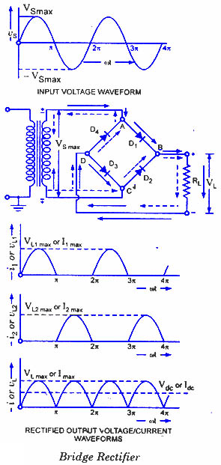

**Filter:**

Capacitive filter is used in this project. It removes the ripples from the output of rectifier and smoothens the D.C. Output received from this filter is constant until the mains voltage and load is maintained constant. However, if either of the two is varied, D.C. voltage received at this point changes. Therefore a regulator is applied at the output stage.



**Voltage regulator:**

As the name itself implies, it regulates the input applied to it. A voltage regulator is an electrical regulator designed to automatically maintain a constant voltage level. In this project, power supply of 5V and 12V are required. In order to obtain these voltage levels, 7805 and 7812 voltage regulators are to be used. The first number 78 represents positive supply and the numbers 05, 12 represent the required output voltage levels. The L78xx series of three-terminal positive regulators is available in TO-220, TO-220FP, TO-3, D2PAK and DPAK packages and several fixed output voltages, making it useful in a wide range of applications. These regulators can provide local on-card regulation, eliminating the distribution problems associated with single point regulation. Each type employs internal current limiting, thermal shut-down and safe area protection, making it essentially indestructible. If adequate heat sinking is provided, they can deliver over 1 A output current. Although designed primarily as fixed voltage regulators, these devices can be used with external components to obtain adjustable voltage and currents.



**ARDUINO**

### Overview:

The Arduino Uno is a microcontroller board based on the ATmega328 ([datasheet](http://www.atmel.com/dyn/resources/prod_documents/doc8161.pdf)). It has 14 digital input/output pins (of which 6 can be used as PWM outputs), 6 analog inputs, a 16 MHz ceramic resonator, a USB connection, a power jack, an ICSP header, and a reset button. It contains everything needed to support the microcontroller; simply connect it to a computer with a USB cable or power it with a AC-to-DC adapter or battery to get started.

The Uno differs from all preceding boards in that it does not use the FTDI USB-to-serial driver chip. Instead, it features the Atmega16U2 (Atmega8U2 up to version R2) programmed as a USB-to-serial converter.  
The Uno board has a resistor pulling the 8U2 HWB line to ground, making it easier to put into [DFU mode](http://arduino.cc/en/Hacking/DFUProgramming8U2).

**The board has the following new features:**

1. pinout: added SDA and SCL pins that are near to the AREF pin and two other new pins placed near to the RESET pin, the IOREF that allow the shields to adapt to the voltage provided from the board. In future, shields will be compatible with both the board that uses the AVR, which operates with 5V and with the Arduino Due that operates with 3.3V. The second one is a not connected pin, that is reserved for future purposes.

* Stronger RESET circuit.
* Atmega 16U2 replace the 8U2.

"Uno" means one in Italian and is named to mark the upcoming release of Arduino 1.0. The Uno and version 1.0 will be the reference versions of Arduino, moving forward. The Uno is the latest in a series of USB Arduino boards, and the reference model for the Arduino platform; for a comparison with previous versions, see the [index of Arduino boards](http://arduino.cc/en/Main/Boards).

### Summary

|  |  |
| --- | --- |
| Microcontroller | ATmega328 |
| Operating Voltage | 5V |
| InputVoltage (recommended) | 7-12V |
| Input Voltage (limits) | 6-20V |
| Digital I/O Pins | 14 (of which 6 provide PWM output) |
| Analog Input Pins | 6 |
| DC Current per I/O Pin | 40 mA |
| DC Current for 3.3V Pin | 50 mA |
| Flash Memory | 32 KB (ATmega328) of which 0.5 KB used by bootloader |
| SRAM | 2 KB (ATmega328) |
| EEPROM | 1 KB (ATmega328) |
| Clock Speed | 16 MHz |
| Length | 68.6 mm |
| Width | 53.4 mm |
| Weight | 25 g |

### Schematic & Reference Design

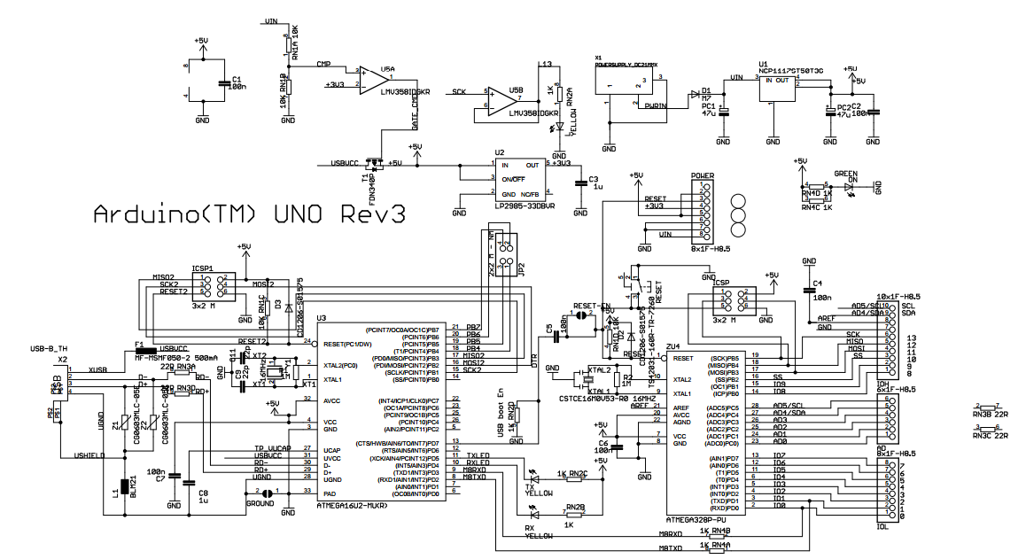**Note:** The Arduino reference design can use an Atmega8, 168, or 328, Current models use an ATmega328, but an Atmega8 is shown in the schematic for reference. The pin configuration is identical on all three processors.

Power

The Arduino Uno can be powered via the USB connection or with an external power supply. The power source is selected automatically.

External (non-USB) power can come either from an AC-to-DC adapter (wall-wart) or battery. The adapter can be connected by plugging a 2.1mm center-positive plug into the board's power jack. Leads from a battery can be inserted in the Gnd and Vin pin headers of the POWER connector.

The board can operate on an external supply of 6 to 20 volts. If supplied with less than 7V, however, the 5V pin may supply less than five volts and the board may be unstable. If using more than 12V, the voltage regulator may overheat and damage the board. The recommended range is 7 to 12 volts.

**The power pins are as follows:**

* **VIN.** The input voltage to the Arduino board when it's using an external power source (as opposed to 5 volts from the USB connection or other regulated power source). You can supply voltage through this pin, or, if supplying voltage via the power jack, access it through this pin.
* **5V.** This pin outputs a regulated 5V from the regulator on the board. The board can be supplied with power either from the DC power jack (7 - 12V), the USB connector (5V), or the VIN pin of the board (7-12V). Supplying voltage via the 5V or 3.3V pins bypasses the regulator, and can damage your board. We don't advise it.
* **3V3.** A 3.3-volt supply generated by the on-board regulator. Maximum current draw is 50 mA.
* **GND.** Ground pins.
* **IOREF.** This pin on the Arduino board provides the voltage reference with which the microcontroller operates. A properly configured shield can read the IOREF pin voltage and select the appropriate power source or enable voltage translators on the outputs for working with the 5V or 3.3V.

### Memory

The ATmega328 has 32 KB (with 0.5 KB used for the bootloader). It also has 2 KB of SRAM and 1 KB of EEPROM (which can be read and written with the [EEPROM library](http://www.arduino.cc/en/Reference/EEPROM)).

### Input and Output

Each of the 14 digital pins on the Uno can be used as an input or output, using [pinMode()](http://arduino.cc/en/Reference/PinMode), [digitalWrite()](http://arduino.cc/en/Reference/DigitalWrite), and [digitalRead()](http://arduino.cc/en/Reference/DigitalRead) functions. They operate at 5 volts. Each pin can provide or receive a maximum of 40 mA and has an internal pull-up resistor (disconnected by default) of 20-50 kOhms. In addition, some pins have specialized functions:

* **Serial: 0 (RX) and 1 (TX).** Used to receive (RX) and transmit (TX) TTL serial data. These pins are connected to the corresponding pins of the ATmega8U2 USB-to-TTL Serial chip.
* **External Interrupts: 2 and 3.** These pins can be configured to trigger an interrupt on a low value, a rising or falling edge, or a change in value. See the [attachInterrupt()](http://arduino.cc/en/Reference/AttachInterrupt) function for details.
* **PWM: 3, 5, 6, 9, 10, and 11.** Provide 8-bit PWM output with the [analogWrite()](http://arduino.cc/en/Reference/AnalogWrite) function.
* **SPI: 10 (SS), 11 (MOSI), 12 (MISO), 13 (SCK).** These pins support SPI communication using the [SPI library](http://arduino.cc/en/Reference/SPI).
* **LED: 13.** There is a built-in LED connected to digital pin 13. When the pin is HIGH value, the LED is on, when the pin is LOW, it's off.

The Uno has 6 analog inputs, labelled A0 through A5, each of which provide 10 bits of resolution (i.e. 1024 different values). By default they measure from ground to 5 volts, though is it possible to change the upper end of their range using the AREF pin and the [analogReference](http://arduino.cc/en/Reference/AnalogReference)() function. Additionally, some pins have specialized functionality:

* **TWI: A4 or SDA pin and A5 or SCL pin.** Support TWI communication using the [Wire library](http://arduino.cc/en/Reference/Wire).

### Communication

The Arduino Uno has a number of facilities for communicating with a computer, another Arduino, or other microcontrollers. The ATmega328 provides UART TTL (5V) serial communication, which is available on digital pins 0 (RX) and 1 (TX). An ATmega16U2 on the board channels this serial communication over USB and appears as a virtual com port to software on the computer. The '16U2 firmware uses the standard USB COM drivers, and no external driver is needed. However, [on Windows, a .inf file is required](http://arduino.cc/en/Guide/Windows#toc4). The Arduino software includes a serial monitor which allows simple textual data to be sent to and from the Arduino board. The RX and TX LEDs on the board will flash when data is being transmitted via the USB-to-serial chip and USB connection to the computer (but not for serial communication on pins 0 and 1).

A [SoftwareSerial library](http://www.arduino.cc/en/Reference/SoftwareSerial) allows for serial communication on any of the Uno's digital pins.

The ATmega328 also supports I2C (TWI) and SPI communication. The Arduino software includes a Wire library to simplify use of the I2C bus; see the [documentation](http://arduino.cc/en/Reference/Wire) for details. For SPI communication, use the [SPI library](http://arduino.cc/en/Reference/SPI).

### Programming

The Arduino Uno can be programmed with the Arduino software ([download](http://arduino.cc/en/Main/Software)). Select "Arduino Uno from the **Tools > Board** menu (according to the microcontroller on your board). For details, see the [reference](http://arduino.cc/en/Reference/HomePage) and [tutorials](http://arduino.cc/en/Tutorial/HomePage).

The ATmega328 on the Arduino Uno comes preburned with a [bootloader](http://arduino.cc/en/Tutorial/Bootloader) that allows you to upload new code to it without the use of an external hardware programmer. It communicates using the original STK500 protocol ([reference](http://www.atmel.com/dyn/resources/prod_documents/doc2525.pdf), [C header files](http://www.atmel.com/dyn/resources/prod_documents/avr061.zip)).

You can also bypass the bootloader and program the microcontroller through the ICSP (In-Circuit Serial Programming) header using [Arduino ISP](http://arduino.cc/en/Main/ArduinoISP) or similar; see [these instructions](http://arduino.cc/en/Hacking/Programmer) for details.

The ATmega16U2 (or 8U2 in the rev1 and rev2 boards) firmware source code is available . The ATmega16U2/8U2 is loaded with a DFU bootloader, which can be activated by:

* On Rev1 boards: connecting the solder jumper on the back of the board (near the map of Italy) and then resetting the 8U2.
* On Rev2 or later boards: there is a resistor that pulling the 8U2/16U2 HWB line to ground, making it easier to put into DFU mode.

You can then use [Atmel's FLIP software](http://www.atmel.com/dyn/products/tools_card.asp?tool_id=3886) (Windows) or the [DFU programmer](http://dfu-programmer.sourceforge.net/) (Mac OS X and Linux) to load a new firmware. Or you can use the ISP header with an external programmer (overwriting the DFU bootloader). See [this user-contributed tutorial](http://www.arduino.cc/cgi-bin/yabb2/YaBB.pl?num=1285962838) for more information.

### Automatic (Software) Reset

Rather than requiring a physical press of the reset button before an upload, the Arduino Uno is designed in a way that allows it to be reset by software running on a connected computer. One of the hardware flow control lines (DTR) of theATmega8U2/16U2 is connected to the reset line of the ATmega328 via a 100 nano-farad capacitor. When this line is asserted (taken low), the reset line drops long enough to reset the chip. The Arduino software uses this capability to allow you to upload code by simply pressing the upload button in the Arduino environment. This means that the bootloader can have a shorter timeout, as the lowering of DTR can be well-coordinated with the start of the upload.

This setup has other implications. When the Uno is connected to either a computer running Mac OS X or Linux, it resets each time a connection is made to it from software (via USB). For the following half-second or so, the bootloader is running on the Uno. While it is programmed to ignore malformed data (i.e. anything besides an upload of new code), it will intercept the first few bytes of data sent to the board after a connection is opened. If a sketch running on the board receives one-time configuration or other data when it first starts, make sure that the software with which it communicates waits a second after opening the connection and before sending this data.

The Uno contains a trace that can be cut to disable the auto-reset. The pads on either side of the trace can be soldered together to re-enable it. It's labelled "RESET-EN". You may also be able to disable the auto-reset by connecting a 110 ohm resistor from 5V to the reset line; see [this forum thread](http://www.arduino.cc/cgi-bin/yabb2/YaBB.pl?num=1213719666/all) for details.

### USB Over current Protection

The Arduino Uno has a resettable polyfuse that protects your computer's USB ports from shorts and overcurrent. Although most computers provide their own internal protection, the fuse provides an extra layer of protection. If more than 500 mA is applied to the USB port, the fuse will automatically break the connection until the short or overload is removed.

### Physical Characteristics

The maximum length and width of the Uno PCB are 2.7 and 2.1 inches respectively, with the USB connector and power jack extending beyond the former dimension. Four screw holes allow the board to be attached to a surface or case. Note that the distance between digital pins 7 and 8 is 160 mil (0.16"), not an even multiple of the 100 mil spacing of the other pins.

**SWITCHES AND PUSHBUTTONS**

There is nothing simpler than this! This is the simplest way of controlling appearance of some voltage on microcontroller’s input pin. There is also no need for additional explanation of how these components operate.

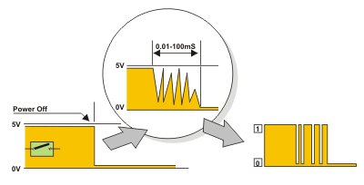

Nevertheless, it is not so simple in practice... This is about something commonly unnoticeable when using these components in everyday life. It is about contact bounce- a common problem with m e c h a n i c a l switches. If contact switching does not happen so quickly, several consecutive bounces can be noticed prior to maintain stable state. The reasons for this are: vibrations, slight rough spots and dirt. Anyway, whole this process does not last long (a few micro- or milliseconds’), but long enough to be registered by the microcontroller. Concerning pulse counter, error occurs in almost 100% of cases!

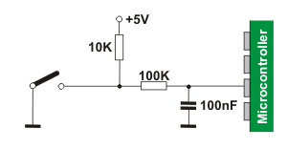

**\**

**3.3 Embedded C language**

**Embedded C** is a set of language extensions for the [C Programming language](http://en.wikipedia.org/wiki/C_Language) by the [C Standards committee](http://en.wikipedia.org/wiki/SC22) to address commonality issues that exist between C extensions for different [embedded systems](http://en.wikipedia.org/wiki/Embedded_systems). Historically, embedded C programming requires nonstandard extensions to the C language in order to support exotic features such as [fixed-point arithmetic](http://en.wikipedia.org/wiki/Fixed-point_arithmetic), multiple distinct [memory banks](http://en.wikipedia.org/wiki/Memory_bank), and basic [I/O](http://en.wikipedia.org/wiki/Input/output) operations.

The C programming language is perhaps the most popular programming language for programming embedded systems. We mentioned other popular programming languages).

Most C programmers are spoiled because they program in environments where not only there is a standard library implementation, but there are frequently a number of other libraries available for use. The cold fact is, that in embedded systems, there rarely are many of the libraries that programmers have grown used to, but occasionally an embedded system might not have a complete standard library, if there is a standard library at all. Few embedded systems have capability for dynamic linking, so if standard library functions are to be available at all, they often need to be directly linked into the executable. Oftentimes, because of space concerns, it is not possible to link in an entire library file, and programmers are often forced to "brew their own" standard c library implementations if they want to use them at all. While some libraries are bulky and not well suited for use on microcontrollers, many development systems still include the standard libraries which are the most common for C programmers.

C remains a very popular language for micro-controller developers due to the code efficiency and reduced overhead and development time. C offers low-level control and is considered more readable than assembly. Many free C compilers are available for a wide variety of development platforms. The compilers are part of an IDEs with ICD support, breakpoints, single-stepping and an assembly window. The performance of C compilers has improved considerably in recent years, and they are claimed to be more or less as good as assembly, depending on who you ask. Most tools now offer options for customizing the compiler optimization. Additionally, using C increases portability, since C code can be compiled for different types of processors.

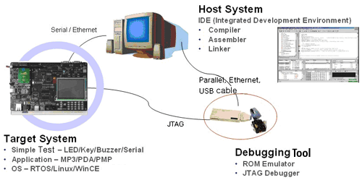

**Figure. 3.4 Embedded System Development Environment**

**LIQUID CRYSTAL DISPLAY**

**LCD screen:**

LCD screen consists of two lines with 16 characters each. Each character consists of 5x7 dot matrix. Contrast on display depends on the power supply voltage and whether messages are displayed in one or two lines. For that reason, variable voltage 0-Vdd is applied on pin marked as Vee. Trimmer potentiometer is usually used for that purpose. Some versions of displays have built in backlight (blue or green diodes). When used during operating, a resistor for current limitation should be used (like with any LE diode).

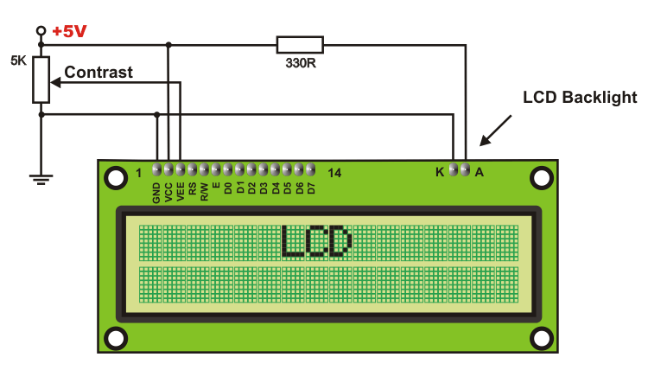

**LCD Basic Commands**

All data transferred to LCD through outputs D0-D7 will be interpreted as commands or as data, which depends on logic state on pin RS:

RS = 1 - Bits D0 - D7 are addresses of characters that should be displayed. Built in processor addresses built in “map of characters” and displays corresponding symbols. Displaying position is determined by DDRAM address. This address is either previously defined or the address of previously transferred character is automatically incremented.

RS = 0 - Bits D0 - D7 are commands which determine display mode. List of commands which LCD recognizes are given in the table below**:**

**CONTRAST CONTROL:**

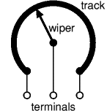To have a clear view of the characters on the LCD, contrast should be adjusted. To adjust the contrast, the voltage should be varied. For this, a pre-set is used which can behave like a variable voltage device. As the voltage of this pre-set is varied, the contrast of the LCD can be adjusted.

**Fig: Variable resistor**

**Potentiometer**

Variable resistors used as potentiometers have all **three terminals** connected.

This arrangement is normally used to **vary voltage**, for example to set the switching point of a circuit with a sensor, or control the volume (loudness) in an amplifier circuit. If the terminals at the ends of the track are connected across the power supply, then the wiper terminal will provide a voltage which can be varied from zero up to the maximum of the supply.

|  |
| --- |
|  |

**LCD INTERFACING WITH THE MICROCONTROLLER:**

Gnd

4 (RS) 1

5 (R/W) 2

6(EN) 3

**LCD**

D0

D1

D2

D3

D4

D5 15

D6 16

D7

P2.0

P2.1

P2.2

**Arduino**  P1.0

P1.1

P1.2

P1.3

P1.4

P1.5

P1.6

P1.7

Vcc

Gnd

PRESET

(CONTRAST CONTROL)

**Vcc**

FOR BACKLIGHT PURPOSE

**IR SENSOR**

**IR Proximity Sensor**

This IR Proximity Sensor is a multipurpose infrared sensor which can be used for obstacle sensing, color detection, fire detection, line sensing, etc and also as an encoder sensor. The sensor provides a digital output.

The sensor outputs a logic one(+5V) at the digital output when an object is placed in front of the sensor and a logic zero(0V), when there is no object in front of the sensor. An onboard LED is used to indicate the presence of an object. This digital output can be directly connected to an Arduino, Raspberry Pi, AVR, PIC, 8051 or any other microcontroller to read the sensor output.

IR sensors are highly susceptible to ambient light and the IR sensor on this sensor is suitably covered to reduce effect of ambient light on the sensor. The sensor has a maximum range of around 40-50 cm indoors and around 15-20 cm outdoors.

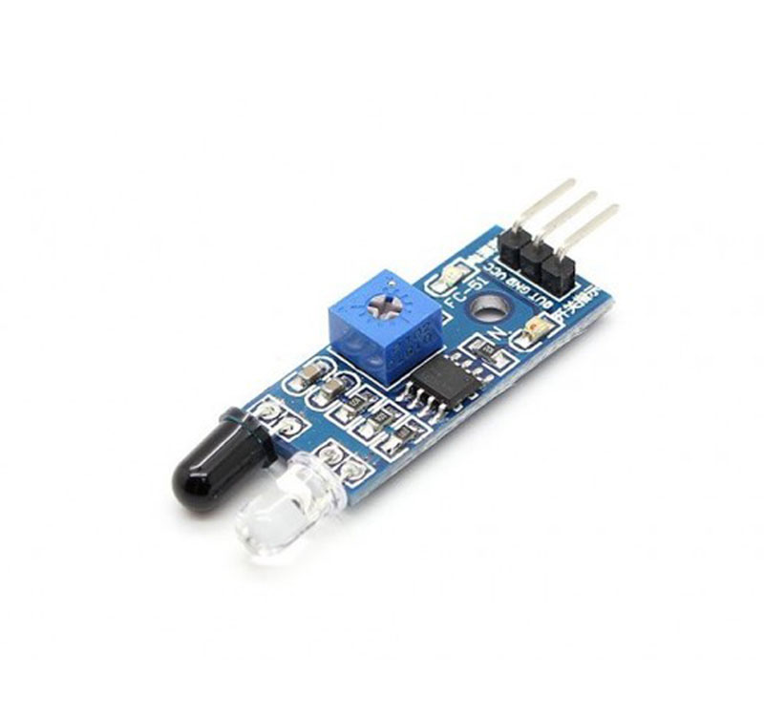

**Features:**

* Can be used for obstacle sensing, color detection (between basic contrasting colors)
* Comes with an easy-to-use digital output
* Can be used for wireless communication and sensing IR remote signals
* Sensor comes with ambient light protection
* The sensor a hole of 3mm diameter for easy mounting

**Specification:**

* Operational Voltage: 5V
* Ambient Light & RGB Color Sensing
* Proximity Sensing
* Gesture Detection
* Operating Range: 4-8in (10-20cm)
* I2C Interface (I2C Address: 0x39)

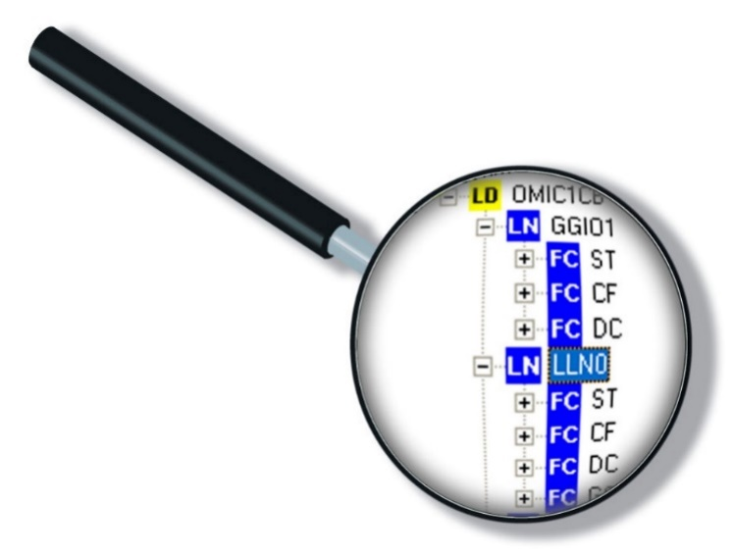

Software Tools

**Arduino software**

The Arduino Uno can be programmed with the Arduino software.

Select "Arduino Uno from the Tools > Board menu (according to the microcontroller on your board). For details, see the reference and tutorials.

The ATmega328 on the Arduino Uno comes pre burned with a boot loader that allows you to upload new code to it without the use of an external hardware programmer. It communicates using the original STK500 protocol (reference, C header files). We can also bypass the boot loader and programs the microcontroller through the ICSP (In-Circuit Serial Programming) header; see these instructions for details. The ATmega16U2 (or 8U2 in the rev1 and rev2 boards) firmware source code is available.

The ATmega16U2/8U2 is loaded with a DFU boot loader, which can be activated by:

•On Rev1 boards: connecting the solder jumper on the back of the board (near the map of Italy) and then resetting the 8U2.

•On Rev2 or later boards: there is a resistor that pulling the 8U2/16U2 HWB line to ground, making it easier to put into DFU mode.

The Arduino Uno has a number of facilities for communicating with a computer, another Arduino, or other microcontrollers. The ATmega328 provides UART TTL (5V) serial communication, which is available on digital pins 0 (RX) and 1 (TX). An ATmega16U2 on the board channels this serial communication over USB and appears as a virtual com port to software on the computer. The '16U2 firmware uses the standard USB COM drivers, and no external driver is needed. However, on Windows, an information file is required. The Arduino software includes a serial monitor which allows simple textual data to be sent to and from the Arduino board. The RX and TX LEDs on the board will flash when data is being transmitted via the USB-to-serial chip and USB connection to the computer (but not for serial communication on pins 0 and 1). A Software Serial library allows for serial communication on any of the Uno's digital pins. The ATmega328 also supports I2C (TWI) and SPI communication. The Arduino software includes a Wire library to simplify use of the I2C bus.

**Node MCU Code**:

#include <ESP8266WiFi.h>

#include "Adafruit_MQTT.h"

#include "Adafruit_MQTT_Client.h"

#define WIFI_SSID "Cricket dreamer" // Your SSID

#define WIFI_PASS "7981252711" // Your password

//#define WIFI_SSID "RK" // Your SSID

//#define WIFI_PASS "rkhr2020" // Your password

/************************* Adafruit.io Setup *********************************/

#define AIO_SERVER "io.adafruit.com"

#define AIO_SERVERPORT 1883

#define AIO_USERNAME "Sainath0323"

#define AIO_KEY "aio_Dffu39oYM6FR1oEGxTF2dBvpW6m3"

WiFiClient client;

Adafruit_MQTT_Client mqtt(&client, AIO_SERVER, AIO_SERVERPORT, AIO_USERNAME, AIO_KEY);

// Setup a feed called 'potValue' for publishing.

// Notice MQTT paths for AIO follow the form: <username>/feeds/<feedname>

Adafruit_MQTT_Publish party1 = Adafruit_MQTT_Publish(&mqtt, AIO_USERNAME "/feeds/party1");

Adafruit_MQTT_Publish party2 = Adafruit_MQTT_Publish(&mqtt, AIO_USERNAME "/feeds/party2");

void MQTT_connect();

uint16_t party1value = 0;

uint16_t party2value = 0;

char p1v[20]= "0";

char p2v[20]= "0";

char winner[20] = "NIL";

int updatei=0;

String incomingdata;

String rp1value;

String rp2value;

void setup() {

Serial.begin(9600);

// Connect to WiFi access point.

Serial.println(); Serial.println();

Serial.print("Connecting to ");

Serial.println(WIFI_SSID);

WiFi.begin(WIFI_SSID, WIFI_PASS);

while (WiFi.status() != WL_CONNECTED) {

delay(500);

Serial.print(".");

}

Serial.println();

Serial.println("WiFi connected");

Serial.println("IP address: ");

Serial.println(WiFi.localIP());

}

void loop() {

MQTT_connect();

if(updatei==0){

updateparty();;

updatei=1;

}

if (Serial.available() > 0) {

incomingdata = Serial.readString();

serial.print("Read:"); Serial.println(incomingdata);

if (incomingdata.startsWith("*")) {

Serial.println("--- STAR CAME --- ");

incomingdata.remove(0, 1);

Serial.print("AFTER REMOVE UPDATE INCOMING DATA:"); Serial.println(incomingdata);

rp1value = getValue(incomingdata, '/', 0); Serial.print(F("PARTY 1 COUNT: ")); Serial.println(rp1value);

rp2value = getValue(incomingdata, '/', 1); Serial.print(F("PARTY 2 COUNT: ")); Serial.println(rp2value);

delay(500);

rp1value.toCharArray(p1v, rp1value.length() + 1);

rp2value.toCharArray(p2v, rp2value.length() + 1);

delay(2500);

/* if(rp2value=="100")

{

Serial.println("GAS data");

if (!party3.publish("GAS DETECTED")) {

Serial.println(F("PARTY 3 Failed"));

}

Else

{

Serial.println(F("PARTY 3 OK!"));

}

}

if(rp3value=="100")

{

Serial.println("LDR data");

if (!party3.publish("DARKNESS occured")) {

Serial.println(F("PARTY 3 Failed"));

}

else

{

Serial.println(F("PARTY 3 OK!"));

}

}

if(rp4value=="100")

{

Serial.println("FIRE data");

if (!party3.publish("FIRE occured")) {

Serial.println(F("PARTY 3 Failed"));

} else {

Serial.println(F("PARTY 3 OK!"));

}

}

if(rp5value=="100")

{

Serial.println("EMERGENCY data");

if (!party3.publish("EMERGENCY observed")) {

Serial.println(F("PARTY 4Failed"));

} else {

Serial.println(F("PARTY 4 OK!"));

}

}*/

updateparty();

delay(6000);

}

}

void updateparty() {

if (!party1.publish(p1v)) {

Serial.println(F("PARTY 1 Failed"));

}

else

{

Serial.println(F("PARTY 1 OK!"));

if (!party2.publish(p2v)) {

Serial.println(F("PARTY 2 Failed"));

} else {

Serial.println(F("PARTY 2 OK!"));

}

}

void MQTT_connect() {

int8_t ret;

// Stop if already connected.

if (mqtt.connected()) {

return;

}

Serial.print("Connecting to MQTT... ");

uint8_t retries = 3;

while ((ret = mqtt.connect()) != 0) { // connect will return 0 for connected

Serial.println(mqtt.connectErrorString(ret));

Serial.println("Retrying MQTT connection in 5 seconds...");

mqtt.disconnect();

delay(5000); // wait 5 seconds

retries--;

if (retries == 0) {

// basically die and wait for WDT to reset me

while (1);

}

}

Serial.println("MQTT Connected!");

}

String getValue(String data, char separator, int index)

{

int found = 0;

int strIndex[] = { 0, -1 };

int maxIndex = data.length() - 1;

for (int i = 0; i <= maxIndex && found <= index; i++) {

if (data.charAt(i) == separator || i == maxIndex) {

found++;

strIndex[0] = strIndex[1] + 1;

strIndex[1] = (i == maxIndex) ? i + 1 : i;

}

}

return found > index ? data.substring(strIndex[0], strIndex[1]) : "";

}

**Pulse Code**

#include <Wire.h>

#include <LiquidCrystal_I2C.h>

LiquidCrystal_I2C lcd(0x27,16,2);

const int buttonPin1 = 2; // D4 mg

const int buttonPin2 = 3; // D4 mg

const int dc11 = 4; // D4 mg

const int dc12 = 5; // D4 mg

const int dc21 = 6; // D4 mg

const int dc22 = 7; // D4 mg

/************************ Example Starts Here *******************************/

int buttonState1 = 1; // variable for reading the pushbutton status

int buttonState2 = 1; // variable for reading the pushbutton status

void setup() {

// start the serial connection

Serial.begin(9600);

pinMode(buttonPin1, INPUT_PULLUP);

pinMode(buttonPin2, INPUT_PULLUP);

pinMode(dc11, OUTPUT);

pinMode(dc12, OUTPUT);

pinMode(dc21, OUTPUT);

pinMode(dc22, OUTPUT);

lcd.begin();

lcd.backlight();

lcd.setCursor(0,0);

lcd.print("IOT PARKING SLOT ");

lcd.setCursor(0,1);

lcd.print("MONITORINGOVER IOT");

digitalWrite(dc11,LOW);

digitalWrite(dc12,LOW);

digitalWrite(dc21,LOW);

digitalWrite(dc22,LOW);

delay(2000);

lcd.clear();

}

void loop() {

lcd.clear();

// Turn on the blacklight and print a message.

buttonState1 = digitalRead(buttonPin1);

buttonState2 = digitalRead(buttonPin2);

delayMicroseconds(2);

delay(1000);

// grab the current state of the photocell

if (buttonState1 == LOW) {

digitalWrite(dc11,HIGH);

digitalWrite(dc12,LOW);

digitalWrite(dc21,LOW);

digitalWrite(dc22,LOW);

lcd.setCursor(0,0);

lcd.print("SLOT1");

lcd.setCursor(0,1);

lcd.print("FULL");

Serial.print("*");

Serial.print(String(100));//slot1

Serial.print("/");

Serial.print(String(0));//slot2

delay(3000);

delay(3000);

digitalWrite(dc11,LOW);

digitalWrite(dc12,LOW);

}

if (buttonState1 == HIGH) {

digitalWrite(dc11,LOW);

digitalWrite(dc12,LOW);

lcd.setCursor(0,0);

lcd.print("SLOT1");

lcd.setCursor(0,1);

lcd.print("EMPTY");

delay(2000);

}

if (buttonState2 == LOW) {

//lcd.clear();

digitalWrite(dc21,HIGH);

digitalWrite(dc22,LOW);

digitalWrite(dc11,LOW);

digitalWrite(dc12,LOW);

lcd.setCursor(7,0);

lcd.print("SLOT2");

lcd.setCursor(7,1);

lcd.print("FULL");

Serial.print("*");

Serial.print(String(0));//temp

Serial.print("/");

Serial.print(String(100));//gas

delay(3000);

digitalWrite(dc21,LOW);

digitalWrite(dc22,LOW);

}

if ((buttonState1 == LOW)&&(buttonState2 == LOW)) {

lcd.clear();

lcd.setCursor(0,0);

lcd.print("SLOT1");

lcd.setCursor(0,1);

lcd.print("FULL");

lcd.setCursor(7,0);

lcd.print("SLOT2");

lcd.setCursor(7,1);

lcd.print("FULL");

Serial.print("*");

Serial.print(String(100));//temp

Serial.print("/");

Serial.print(String(100));//gas

digitalWrite(dc11,HIGH);

digitalWrite(dc12,LOW);

digitalWrite(dc21,HIGH);

digitalWrite(dc22,LOW);

delay(3000);

digitalWrite(dc11,LOW);

digitalWrite(dc12,LOW);

digitalWrite(dc21,LOW);

digitalWrite(dc22,LOW);

delay(3000);

digitalWrite(dc21,LOW);

digitalWrite(dc22,LOW);

}

if (buttonState2 == HIGH) {

lcd.setCursor(7,0);

lcd.print("SLOT2");

lcd.setCursor(7,1);

lcd.print("EMPTY");

digitalWrite(dc21,LOW);

digitalWrite(dc22,LOW);

delay(2000);

}

}

**CONCLUSION**

The project “**IOT Based Parking System”** been successfully designed and tested. It has been developed by integrating features of all the hardware components used. Presence of every module has been reasoned out and placed carefully thus contributing to the best working of the unit. Secondly, using highly advanced IC’s and with the help of growing technology the project has been successfully implemented.

**BIBILOGRAPHY**

* 1. www.howstuffworks.com
  2. EMBEDDED SYSTEM BY RAJ KAMAL
  3. 8052 MICROCONTROLLER AND EMBEDDED SYSTEMS BY MAZZIDI
  4. Magazines
  5. Electronics for you
  6. Electrikindia
  7. [www.google.com](http://www.google.com)
  8. [www.electronicprojects.com](http://www.electronicprojects.com)

**Output:**

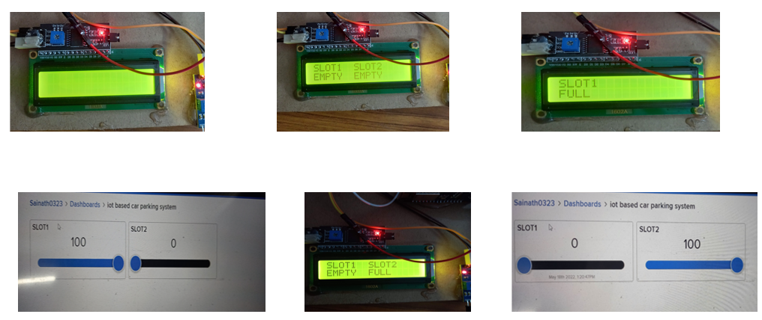

**Working Stills**

